**Cursors**

**Calculate Interest for Fixed Deposit Amount Using Cursors.**

**set intrest as 0 and then update it using the program.**

**set 10% intrest for amount less than or equal to 1000.**

**20% for more then 1000 to 5000.**

**30% for above 5000.**

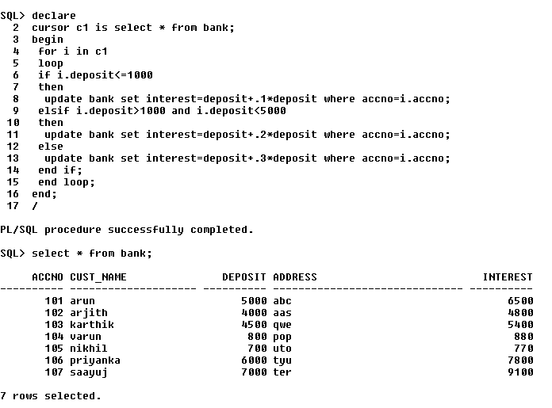

**2. Calculate Electricity Bill Using Cursors**

declare

cursor c is select * from bills;

begin

for i in c

loop

if i.unit<=100 then

update bills set charge=i.unit*0.1 where bno=i.bno;

elsif i.unit>100 and i.unit<=200 then

update bills set charge=i.unit*0.2 where bno=i.bno;

else

update bills set charge=i.unit*0.3 where bno=i.bno;

end if;

end loop;

end;

/

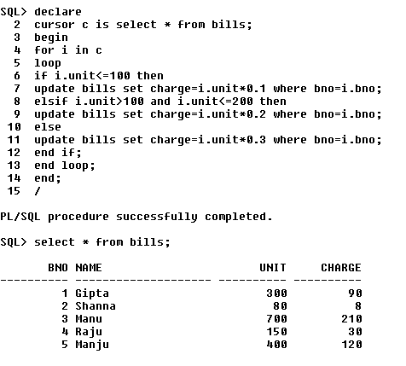

**3.Write PL/SQL code to UPDATE values in created tables by using Implicit Cursors.**

set serveroutput on;

declare

row number(20);

begin

update elecs set unit=unit+100;

if sql%notfound then

dbms_output.put_line('no row updated');

elsif sql%found then

dbms_output.put_line('rows updated');

row:=sql%rowcount;

end if;

end;

/

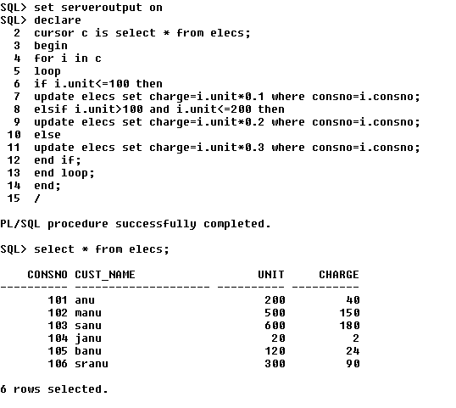

**4.Given the table works(emp_id,company_name,salary).write a cursor to**

**select the three highest paid employees from the table.**

SQL> create table wor(emp_id integer,company_name varchar(20),salary number);

Table created.

SQL> insert into wor values(&emp_id,'&comp_name',&salary);

Enter value for emp_id: 101

Enter value for comp_name: qwe

Enter value for salary: 3000

old 1: insert into wor values(&emp_id,'&comp_name',&salary)

new 1: insert into wor values(101,'qwe',3000)

1 row created.

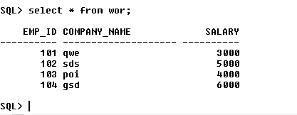

set serveroutput on;

SQL> declare

2 cursor c1 is select * from(select * from wor order by salary desc) where rownum<=4;

3 r c1%rowtype;

4 begin

5 open c1;

6 loop

7 fetch c1 into r;

8 exit when c1 %notfound;

9 dbms_output.put_line(r.emp_id||' '||r.company_name||' '||r.salary);

10 end loop;

11 end;

12 /

104 gsd 6000

102 sds 5000

103 poi 4000

101 qwe 3000

PL/SQL procedure successfully completed.

